Module 09

Title: Case Study on Fog Computing

Objective: To have a basic understanding of implementation/applications of fog computing.

Theory:
Fog computing is a promising computing paradigm that extends cloud computing to the edge of networks. Similar to cloud computing but with distinct characteristics, fog computing faces new security and privacy challenges besides those inherited from cloud computing. Fog computing is introduced as an intermediate layer between the clients and the Cloud. It brings computing, storage, management, and network services among others, closer to the sensor/actuator nodes.
The Internet-of-Things (IoT) is a self-configuring and adaptive network which connects real-world things to the Internet enabling them to communicate with other connected objects leading to the realization of a new range of ubiquitous services.The IoT is already around us connecting wearable devices, smart cars and smart home systems. It is expected that more than 50 billion devices will be connected to the Internet by 2020
The introduction of such a huge number of connected devices requires a scalable architecture to accommodate them without any degradation of the quality of service demanded by applications. In addition, the majority of the devices that make up the Internet of Things are resource-constrained; resources, such as computing power, energy, bandwidth and storage are scarce. These constraints limit the deployment scenarios of applications using such IoT devicesFog computing layer brings computing, network and storage services closer to the end-nodes in IoT. Compared to Cloud computing, this computing layer is highly distributed and introduces additional services to end-devices located in the perception layer.

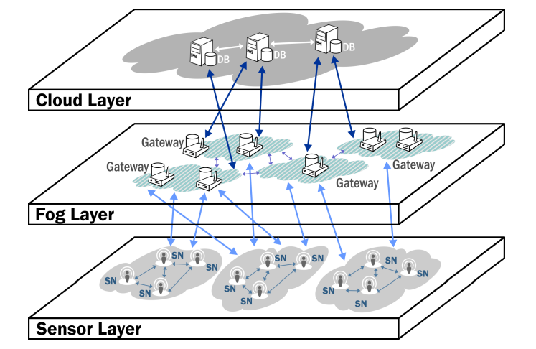
Fig. High level overview of fog based IoT

Fog Computing Basics
The introduction of the IoT brings billions of devices to the Internet and the majority of these devices are resource-constrained. To overcome the challenges of these devices and meet the requirements of the application domain, the demand for an intermediate computing layer becomes evident. The concept of fog computing is the latest descendant in the line of physical separation of functional units. It is a computing layer closer to the perception layer, where the sensors and actuators reside, and provides computing, networking, and storage services.
Characteristics of the Fog layer
In contrast to the Cloud layer, the Fog layer is closer to the perception layer and this proximity provides a range of advantages that characterise the layer. One of the immediate benefits over the Cloud is its location-awareness. Such awareness comes due to the largescale geographical distribution of the devices that make up the Fog layer. The location-awareness of the Fog layer can be utilized to address multiple functional and non-functional requirements of IoT applications, such as mobility and security. Another closely related characteristics of the Fog layer is its large scale distribution in contrast to the centralized Cloud layer. Centralization in this context is relative; the Cloud layer is centralized as seen from the client side. Looking from the organization of the servers in the cloud, however, it is geographically distributed but not at the scale expected from the Fog layer. For instance, Cloud service providers such as Amazon have multiple data centers in different regions.The IoT in general is dominated by wireless networks. There are many wireless protocols, mostly tailored for low-power operation, coverage or bandwidth.
Design and Organization of the Fog layer
Based on the characteristics of the Fog layer presented in the previous section and the possible set of services highlighted in the following section, the Fog layer can Chapter 1 Fog Computing Fundamentals in The Internet-of-Things 7 be organized in an efficient way to address the requirements. This section is by no means comprehensive and detailed enough for build a usable intermediate layer, but instead gives an introductory information that will be dealt in more details in later chapters. To begin with, consider a network gateway or a wireless hot-spot serving clients in its vicinity. The role of such a gateway is to pass network packets to the back-end infrastructure which is connected to the Internet
Fog Computing Services
This layer takes advantage of its proximity to the sensor layer and provides services that are extensions of the cloud layer and also unique ones that are feasible only at this layer. This section gives an overview of a subset of possible services at the fog layer and the related advantages that enable IoT. These services are organized into Compute, Storage and Network services.
Computing services
The limitations of computing power of the devices in the perception layer has led to the introduction of remote processing approaches. Processing at the Fog layer is not only motivated by the constraint of processing power at sensor nodes, but also by the desired location of computing to better meet system requirements and maintain energy efficiency.
Storage Services
A huge amount of data can be generated by the sensor nodes and there are billions of these sensor devices around. The storage available in the devices at the perception layer is not often sufficient to store even a one-day data considering the rate of data generation. Combined with the computing service, the stored data can be filtered, analyzed, and compressed for efficient transmission or for learning local information regarding the system behaviour. In cases where the communication may not be robust, the storage services help enhance the reliability of the system by maintaining proper system behavior for client nodes.
Communication Services
The communication in the Internet-of-Things is dominated by wireless nodes. Due to the resource constraints in the perception layer, these wireless protocols are optimized for low power operation, narrow-band transmission or longer range of coverage. Currently, a long list of alternative protocols are available in the market. This helps in managing sub-networks of sensors and actuators providing security, channeling messages among devices and enhancing the reliability of the system. In addition, this layer can provide interoperability of disparate protocols by listing and interpreting the representation format. Moreover, the Fog layer provides visibility of devices that are non-IP-based to be accessible through the Internet.

Conclusion:
Fog computing is a promising computing paradigm that extends cloud computing to the edge of networks. Similar to cloud computing but with distinct characteristics, fog computing faces new security and privacy challenges besides those inherited from cloud computing.

Program  Execution/  formation/  correction/  ethical practices  (07) | Documentation  (02) | Punctuality  (01) | Viva Answer  (05) | Experiment  Marks (15) | Teacher Signature with date

